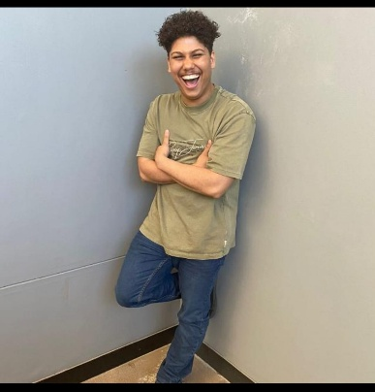

Referances
- Stephen Pedro
0760725156
- Phillip Human
0833958662
- Justin Hector
0829487547

Personal details
Rocco Given Visagie
26 Kameeldoring Street
Rouxville
Kuilsriver
Cape Town
7580
220343527@mycput.ac.za
0609208354

Work Experience
Capita Call Centre
Customer Experience Advisor – Marks & Spencer Campaign
June 2022 – January 2024
Deli Den Urban Farmhouse
Cashier / Merchandiser / Sales Assistant
2022
Footgear – Access Park
Sales Associate
2021
Dis-Chem
Cashier / Merchandiser
2019
Ignite Events Company
Bartender / Waiter
2016
Spur Steak Ranches
Waiter
2015

EDUCATION
Cape Peninsula University of Technology – District Six Campus
Diploma: ICT in Applications Development
Final Year (Current)

De Kuilen High School
National Senior Certificate (Bachelor’s Pass)
Completed in 2015

Technical Skills
- Project Management
- Java Programming
- Debugging
- JavaScript Programming
- Usability Testing
- UX/UI Design

Professional Development
Course
Organization, Location
20XX

Course
Organization, Location
20XX

Workshop
Organization, Location
20XX

Rocco Given Visagie

Career Objective-Full Stack developer
Passionate about building digital experiences that are visually compelling, intuitive, and a joy to use. I bridge the gap between design and development—leveraging strong Java skills to write clean, scalable code that brings polished concepts to life. Committed to crafting seamless end-to-end solutions that balance aesthetic detail with technical integrity.

